***Mini project Report***

***On***

**App Development using Flutter SDK: Rental Room Finder**



By

Laxman Chandrasali (201700491)

Adhyyan Tripathi (201700403)

Nikhil Sharma (201700523)

**Group Id – 17**

*In the partial fulfilment of requirements for the award of degree in*

*Bachelor of Technology in Computer Science and Engineering*

*(2020)*

**Sikkim Manipal Institute of Technology, Majitar**

**DEPARTMENT OF COMPUTER SCIENCE AND ENGINEERING**

**SIKKIM MANIPAL INSTITUTE OF TECHNOLOGY (**A

Constituent college of Sikkim Manipal University) MAJITAR,

RANGPO, EAST SIKKIM – 737136

**PROJECT COMPLETION CERTIFICATE**

This is to certify that the below mentioned student of Sikkim Manipal Institute of Technology has worked under my supervision and guidance from **8th** **January 2020 to** **15th May 2020** and has successfully completed the project entitled **“Title of Project”** inpartial fulfilment of the requirements for the award of Bachelor of Technology in Computer Science and Engineering.

|  |  |  |
| --- | --- | --- |
| University Registration No | Name of Student | Course |
| **2017491** | **Laxman Chandrasali** | **B.Tech (CSE)** |
| **201700523** | **Nikhil Umakant Sharma** | **B.Tech (CSE)** |
| **201700403** | **Adhyyan Tripathi** | **B.Tech (CSE)** |
|  |  |  |

**Dependra Dhakal**

Assistant Professor

Department of Computer Science and Engineering

Sikkim Manipal institute of Technology

Majhitar, Sikkim – 737136

**PROJECT REVIEW CERTIFICATE**

This is to certify that the work recorded in this project report entitled **“App**

**Development using Flutter SDK: Rental Room Finder”** has been jointly carried out by **Adhyyan Tripathi (Reg. 201700403), Nikhil Umakant Sharma (Reg. 201700523) and Laxman Chandrasali (Reg. 201700491)** of Computer Science & EngineeringDepartment of Sikkim Manipal Institute of Technology in partial fulfillment of the requirements for the award of Bachelor of Technology in Computer Science and Engineering. This report has been duly reviewed by the undersigned and recommended for final submission for Mini Project Viva Examination.

**Dependra Dhakal**

Assistant Professor

Department of Computer Science and Engineering

Sikkim Manipal Institute of Technology

Majhitar, Sikkim – 737136

**CERTIFICATE OF ACCEPTANCE**

This is to certify that the below mentioned students of Computer Science & Engineering Department of Sikkim Manipal Institute of Technology (SMIT) have worked under the supervision of **Dependra Dhakal**  of Assistant Professor, Department of Computer Science and Engineering from **8th** **January 2020 to 15th** **May 2020** on the project entitled

**“AppDevelopment using Flutter SDK: Rental Room Finder”.**

The project is hereby accepted by the Department of Computer Science & Engineering, SMIT in partial fulfillment of the requirements for the award of Bachelor of Technology in Computer Science and Engineering.

|  |  |  |
| --- | --- | --- |
| University Registration No | Name of Student | Project Venue |
| **201700403**  **201700523**  **201700491** | **Adhyyan Tripathi**  **Nikhil Umakant Sharma**  **Laxman Chandrasali** | **SMIT** |

**Prof. (Dr.) Kalpana Sharma**

Professor & Head of Department

Computer Science & Engineering Department

Sikkim Manipal Institute of Technology

Majhitar, Sikkim – 737136

**DECLARATION**

We, the undersigned, hereby declare that the work recorded in this project report entitled “**AppDevelopment using Flutter SDK: Rental Room Finder**” in partial fulfillment for the requirements of award of B.Tech (CSE) from Sikkim Manipal Institute of Technology (A constituent college of Sikkim Manipal University) is a faithful and bonafide project work carried out at “**SIKKIM** **MANIPAL INSTITUTE OF TECHNOLOGY**” under the supervision and guidance of **Guide’s Name,** Assistant Professor, Department of Computer Science and Engineering.

The results of this investigation reported in this project have so far not been reported for any other Degree or any other Technical forum.

The assistance and help received during the course of the investigation have been duly acknowledged.

**Nikhil Umakant Sharma (Reg. No.-201700523)**

**Adhyyan Tripathi (Reg. No.-2017403)**

**Laxman Chandrasali (Reg. No.-2017491)**

**ACKNOWLEDGMENT**

We take this opportunity to acknowledge indebtedness and deep sense of gratitude to my guide **Guide’s name** whose valuable guidance and kind supervision gave us throughout the course which shaped the present work as it shows.

We pay our deep sense of gratitude to **Prof. (Dr.) Kalpana Sharma, H.O.D, Computer** **Science & Engineering Department, Sikkim Manipal Institute of Technology** forgiving us the opportunity to work on this project and provided all support required.

We obliged to our project coordinators **Dr. Sandeep Gurung, Mr. Santanu Kr. Misra,** **Mr. Biraj Upadhyaya and Ms. Nitisha Pradhan** for elevating, inspiration and kindsupervision in completion of our project.

We would also like to thank any other staff of **Computer Science & Engineering**

**Department, Sikkim Manipal Institute of Technology** for giving us continuous

support and guidance that has helped us in completion of our project.

**Nikhil Umakant Sharma (Reg. No.-201700523)**

**Adhyyan Tripathi (Reg. No.-2017403)**

**Laxman Chandrasali (Reg. No.-2017491)**

**DOCUMENT CONTROL SHEET**

|  |  |  |
| --- | --- | --- |
| 1 | Report No | CSE/Mini Project/Internal/B.Tech/C/17/2020 |
|  |  |  |
| 2 | Title of the Report | App Development using Flutter SDK: Rental Room Finder |
|  |  |  |
| 3 | Type of Report | Technical |
|  |  |  |
| 4 | Author | Adhyyan Tripathi, Laxman Chandrasali, Nikhil Sharma |
|  |  |  |
| 5 | Organizing Unit | Sikkim Manipal Institute of Technology |
|  |  |
|  |  |  |
| 6 | Language of the Document | English |
|  |  |  |
| 7 | Abstract | The aim of this project is targeted to reduce the effort of the students who are willing to find the RENTAL ROOMS near the college |
|  |  |  |
| 8 | Security Classification | General |
|  |  |  |
| 9 | Distribution Statement | General |
|  |  |  |

**TABLE OF CONTENTS**

|  |  |  |
| --- | --- | --- |
| **Chapter** | **Title** | **Page No.** |
|  | **Abstract** |  |
| 1. | Introduction |  |
|  | 1.1 General overview of project |  |
|  | 1.2 Literature survey |  |
|  | 1.3 Problem Definition |  |
|  | 1.4 Proposed Solution Strategy |  |
|  | 1.5 Organization of the report |  |
| 2. | Dart |  |
| 3. | Flutter SDK |  |

**List of Contents:**

1. Introduction----------------------------------------------------------------------------------------3
2. Literature Survey---------------------------------------------------------------------------------6
3. Problem Definition-------------------------------------------------------------------------------7
4. Solution Strategy---------------------------------------------------------------------------------7
5. Use Case------------------------------------------------------------------------------------8
6. Class Diagram-------------------------------------------------------------------------------------9
7. Schema of Database----------------------------------------------------------------------------10
8. Gantt Chart----------------------------------------------------------------------------------------11

**Abstract**

In this project, we target to build an android/IOS application using flutter SDK, to reduce the effort of the students who are willing to find the rental rooms near the college. Our application is targeted to be running on android 6.0.X (and upwards) and IOS 8.X (and upwards), this application is backed by real-time database (google firebase). The real-time database is used to store and retrieve data in real time, each and every part of the data required, which is necessary to run our application is stored in the firebase.

The application is built by considering two types of entities, which are user and owner. Both the entities can login in to their respective portals, using their own login pages. Once into their respective portals, the owner can manage his properties or he can add a new property. The user on the other hand can view properties based on his location, or he can search manually. In our application privacy of the owner is a great challenge, which we have tackled by using encryption, which is natively provided in firebase, also only users who are signed in can only the profile of the owners, guest users can only see the property but cannot see the contact details.

1. **Introduction**
   1. **General overview of the project:**

RENTAL ROOMS’s are great alternatives for students as well as for working professionals. In general Students may face the problems finding the RENTAL ROOMS’s near to college. Our application will find the RENTAL ROOMS’s according to the consumers requirements. Functionality of virtual chatbot is available to answer the users queries in no time. Also, it will give the recommendation of top properties in the area according to the user’s requirement. Each property will show nearby stores, ATM’s and much more.

The aim of this project is targeted to reduce the effort of the students who are willing to find the RENTAL ROOMS near the college. As per the current technology there is not any such application or website who provides this service. As of now to find a RENTAL ROOMS in an area we need to manually investigate the available RENTAL ROOMS’s and then also chances are very less to find one specially in the remote area.

In this project we aiming to provide all the possible options according to the requirements specified. Details such as rent, location, images of property and contact details will be provided by us in this application.

Though there are many competitors like Airbnb, but they have not implemented their ideas in remote locations. This application will not only reduce the time but can also compare the expected prices available on different properties and location. Students as well as working professionals can search according to their requirements.

* 1. **Literature Survey:**

|  |  |  |  |  |
| --- | --- | --- | --- | --- |
| **SL No.** | **Author details** | **Papers and Publication** | **Findings** | **Relevance** |
| 1. | Paulo Dinchin | [www.bawp.com](http://www.bawp.com) | Dart Language | Helped in the understanding of dart programming language |
| 2. | Google | <https://firebase.google.com/> | Real time database | Provided us with all the necessary documentation on the realtime -db. |
| 3. | Google | <https://flutter.dev/> | Flutter Framework | Provided us the flutter SDK. |
| 4. | Oyo | <https://www.oyorooms.com/> | Search Mechanism | Helped in the search module implementation, by understanding the variables which needs to be considered. |
| 5. | Google | <https://flutter.dev/docs> | All the components and widgets which we have used in the project. | Provided us with all the necessary documentation on the widgets. |

* 1. **Problem Definition:**

Student’s in any institute find difficult to find RENTAL ROOMS nearby due to unknown place. Also, the process of searching the rooms is very manual and time consuming. Also, this process has no guarantee that the person will find the desired property. Problem comes here due to locations of the property are usually not known or are tired to look around.

If the student is new to the area, they won’t be knowing other places such as restaurants, ATM’s, general stores, etc.

* 1. **Solution Strategy:**

As the student will face lots of problem finding the RENTAL ROOMS’s near to the college, our application will help them find it for them according to their requirement. This process will save the time as well as the expected rent of the property. Our user-friendly UI will show the exact location of the property with the contact details as well as the images of the property.

Each property in our application will also contain the general requirements of the user like restaurant, ATM’s, etc.

We will design our application for both android and iOS devices using Flutter.

The central idea behind Flutter is the use of widgets. It’s by combining different widgets that developers can build the entire UI. Each of these widgets defines a structural element (like a button or menu), a stylistic element (a font or colour scheme), a layout aspect (like padding), and many others.

We will use real time database for storing and retrieving the data.

Firebase Analytics is a cost-free app measurement solution that provides insights on app usage and user engagement.

* 1. **Organization of report:**

1. **Dart:**

Dart is a client-optimized programming language for apps on multiple platforms. It is developed by Google and is used to build mobile, desktop, backend and web applications.

Dart is an object-oriented, class defined, garbage-collected language using a C-style syntax that trans compiles optionally into JavaScript. It supports interfaces, mixing, abstract classes, reified generics, static typing, and a sound type system.

Usage: There are four ways to run Dart code:

Compiled as JavaScript:

To run in mainstream web browsers, Dart relies on a source-to-source compiler to JavaScript. According to the project site, Dart was "designed to be easy to write development tools for, well-suited to modern app development, and capable of high-performance implementations.

Stand-alone:

The Dart software development kit (SDK) ships with a stand-alone Dart VM, allowing Dart code to run in a command-line interface environment. As the language tools included in the Dart SDK are written mostly in Dart, the stand-alone Dart VM is a critical part of the SDK.

Ahead-of-time compiled:

Dart code can be AOT-compiled into machine code (native instruction sets). Apps built with Flutter, a mobile app SDK built with Dart, are deployed to app stores as AOT-compiled Dart code.

Native:

Dart 2.6 with dart2native compiler to compile to self-contained, native executables code. Before Dart 2.6, this feature only exposed this capability on iOS and Android mobile devices via Flutter.

1. **Flutter:**

Flutter is an open-source mobile SDK developer can use to build native-looking Android and iOS applications from the same code base.

Flutter has been around since 2015 when Google introduced it and remained in the beta stage before its official launch in December 2018. Since then, the buzz around Flutter has been growing stronger.

Widgets:

The central idea behind Flutter is the use of widgets. It’s by combining different widgets that developers can build the entire UI. Each of these widgets defines a structural element (like a button or menu), a stylistic element (a font or color scheme), a layout aspect (like padding), and many others.

Benefits of Flutter:

Excellent performance:

Flutter offers outstanding performance for two reasons. First, is uses Dart, which compiles into native code. Second, Flutter has its own widgets, so there’s no need to access OEM ones. As a result, there’s less communication between the app and the platform. These two features of Flutter ensure fast app startup times and fewer performance issues in general.

Compatibility:

Another advantage of Flutter is the fact that it comes with its own widgets that result in fewer compatibility issues. Developers will see fewer problems on different OS versions and can spend less time on testing the app on older OS versions. Also, you can be confident that your app will work on future OS versions.

**Use Case:**

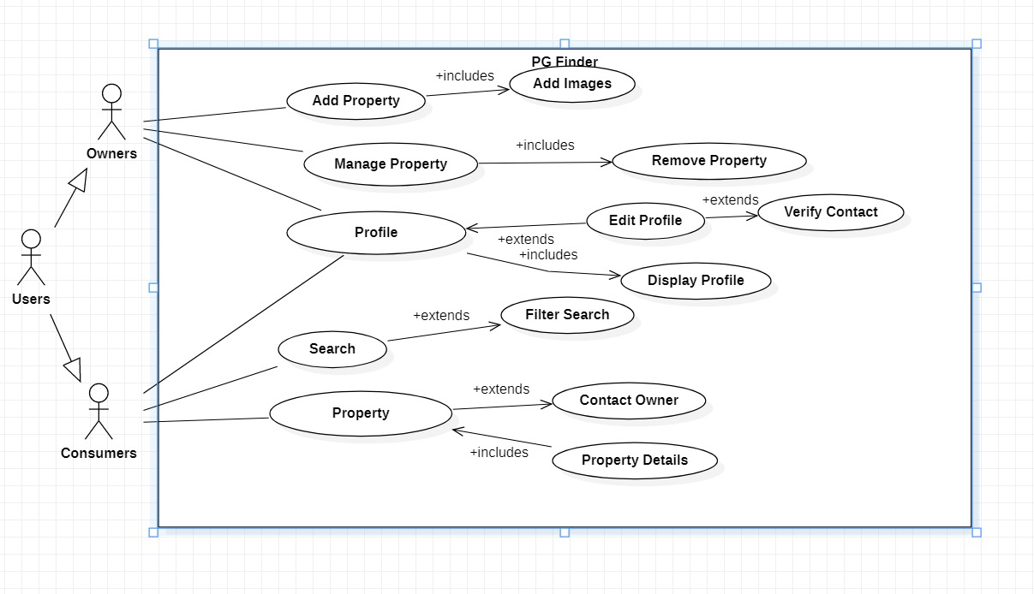

**Class Diagram:**

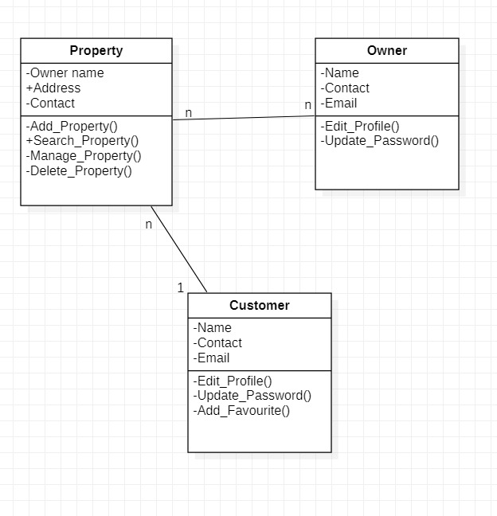

**Schema of Real Time Database:**

Table representation-

Owner -

|  |  |  |  |
| --- | --- | --- | --- |
| Owner Id | Name | Contact | Email |
| Id: 1 | Nikhil Sharma | 9182736455 | [abc@gmail.com](mailto:abc@gmail.com) |
| Id: 2 | Laxman Chandrasali | 9876554321 | [xyz@gmail.com](mailto:xyz@gmail.com) |
| Id: 3 | Adhyyan Tripathi | 9867267327 | [pqr@gmail.com](mailto:pqr@gmail.com) |

User –

|  |  |  |  |
| --- | --- | --- | --- |
| User Id | Name | Contact | Email |
| Id: 1 | Nikhil Sharma | 9182736455 | [abc@gmail.com](mailto:abc@gmail.com) |
| Id: 2 | Laxman Chandrasali | 9876554321 | [xyz@gmail.com](mailto:xyz@gmail.com) |
| Id: 3 | Adhyyan Tripathi | 9867267327 | [pqr@gmail.com](mailto:pqr@gmail.com) |

Realtime-DB representation-

-Owner :

-id:owner 1

-Name

-Contact

-Email

-id:owner 2

-Name

-Contact

-Email

-User:

-id: User 1

-Name

-Contact

-Email

-id: User 2

-Name

-Contact

-Email

**Gantt Chart:**

|  |  |  |  |  |  |
| --- | --- | --- | --- | --- | --- |
| Activity | Jan,20 | Feb,20 | March,20 | April,20 | May,20 |
| Literature survey & References |  |  |  |  |  |
|  |  |  |  |  |
| Problem Identification |  |  |  |  |  |
|  |  |  |  |  |
| Design |  |  |  |  |  |
|  |  |  |  |  |
| Implementation and Testing |  |  |  |  |  |
|  |  |  |  |  |
| Report Writing |  |  |  |  |  |
|  |  |  |  |  |